# HiJack mega Encode Starter Kit User Manual

|  |  |  |  |
| --- | --- | --- | --- |
| Version | Date | Initial | History |
| 0.01 | 2012-12-20 | Ren Kai | Origination |

1. Frame Format
2. Frame format definition

1 start bit, always is low

8 data bits,

1 parity bit, using odd parity

1 stop bit, always is high

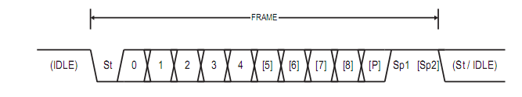

1. Odd parity

If data bits sum is odd, parity bit is low.

If data bits sum is even, parity bit is high.

More detail refer to:

<http://blog.csdn.net/alan0521/article/details/7722823>

1. Manchester encode

Manchester encoding is a balanced 1:2 code, the encoder works by replacing every 1 in the input stream with a rising edge, and every 0 with a falling edge.

1. Starter

When you power on the board and open com utility, pressing reset button can show like this @38400.

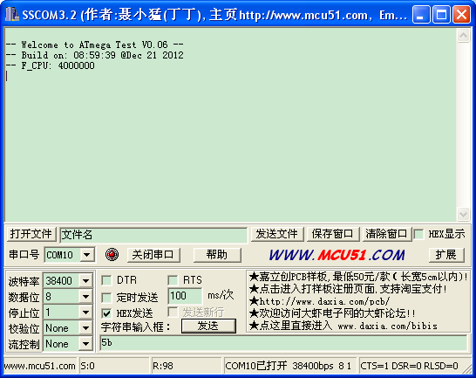

You can input any hex value except 0xFF, then encode module can parser it and output through module’s RED WIRE.

1. Example

This is what I got from oscilloscope when I input different hex from com utility. Our carrier wave is 2KHz square wave.

Input 0xA5, 0b10100101

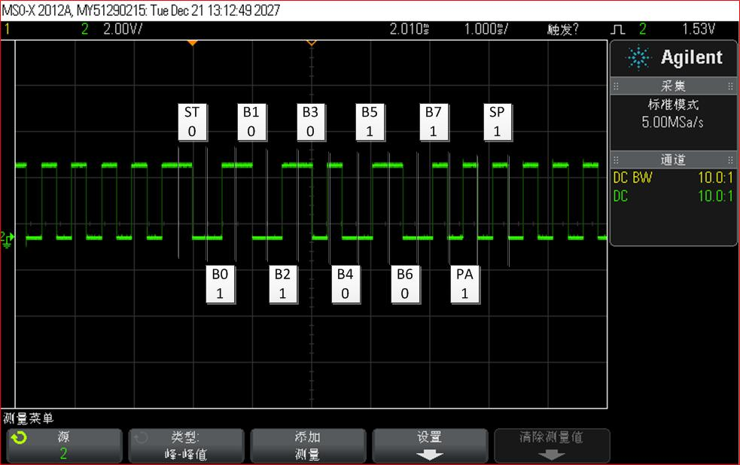

ST: start bit

Bx: data bit

PA: parity bit

SP: stop bit

Input 0x7A, 0b01111010

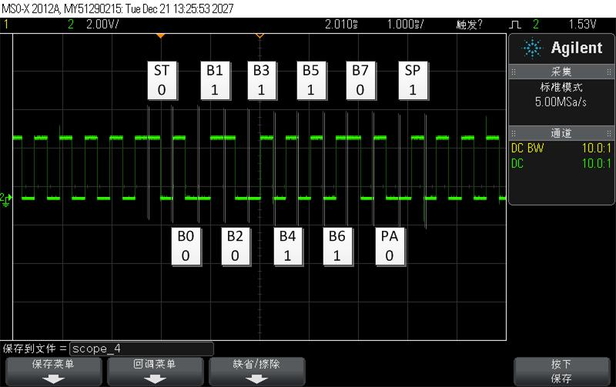

ST: start bit

Bx: data bit

PA: parity bit

SP: stop bit

1. Reference

<http://cdn.energymicro.com/dl/an/pdf/an0054_efm32_phone_audio_jack_interface.pdf>

<http://web.eecs.umich.edu/~prabal/pubs/papers/kuo10hijack-islped.pdf>